# Renew certificate BIP

## Receive certificate

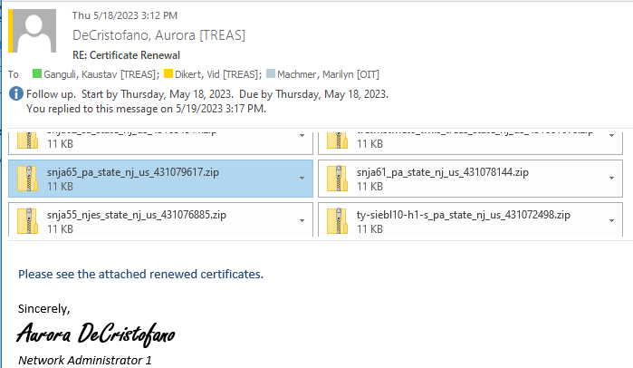

## Locate private keystore

Log into weblogic console –

<https://snja62.sa.state.nj.us:7002/console>

weblogic/siebdev99

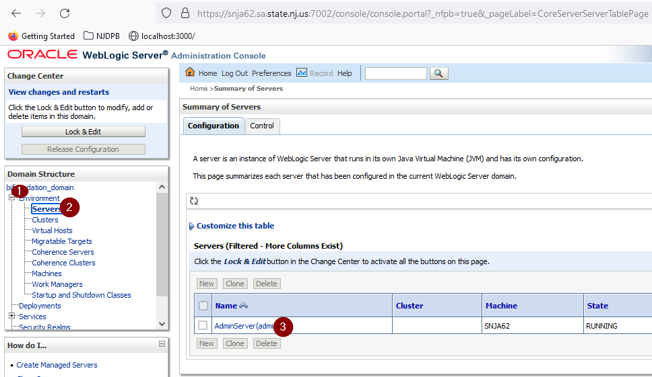

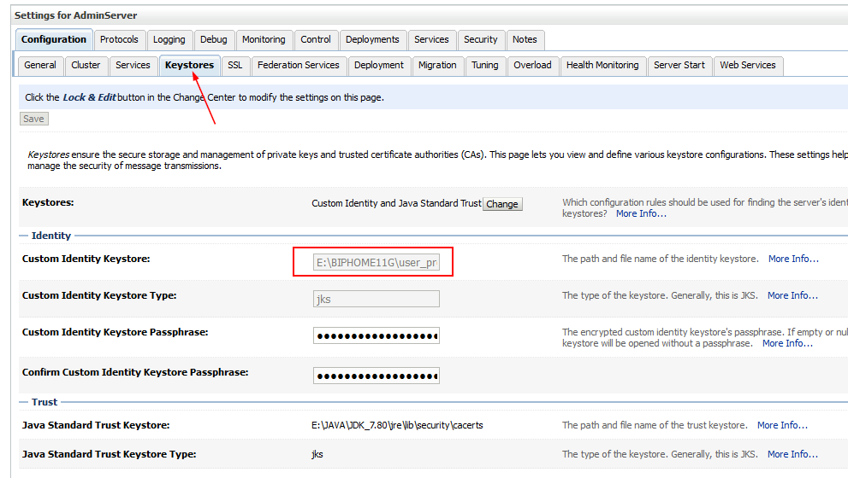

## Download keystore to local and open with keytool-explorer

## Use keytool explorer to add certificate

### Extract the root and intermediate certificates

### Apply certificate reply to the server certificate on the same alias

## Save keystore

## Upload to bip server

## Restart weblogic

## Test